Alshamque Gray
Polk State College
CIS 4305
Professor Giannoni
April 12, 2026
Design and Implementation of a Data Warehouse
Project Design Document

Overview

Today’s world has businesses relying heavily on data to drive day to day and long-term decision making which helps improve overall performance. These companies collect data from various sources like sales transactions, customer interactions, inventory systems and online platforms. Despite this, collecting data alone is not enough for business to just use. A business must be able to take this data and organize, process, and analyze the data to turn it into actionable knowledge. With this in mind, business must have a system in order to provide value to decision makers (Bavdaž et al., 2020).
Business intelligence (BI) is the backbone of organizations when it comes to using data effectively, A well designed BI system will allow a business to analyze historical and current data to identify trends, measure performance, and support strategic planning. Current research shows that a organization that implements BI systems are better equipped to improve performance and make informed decisions (Necochea-Chamorro & Larrea-Goycochea, 2023). In addition to that, companies that are able to stay closely connected to their data are able to quickly respond and be competitive in the dynamic environments (Mohammad Akel, 2025). This project will focus on the design and implantation of a data warehouse and explore how that helps businesses make informed decisions.

System Architecture

Data Sources
At the base of the system, there is multiple raw data sources that is used in the data warehouse. These data sources include sales transactions, customer data, product information, vendor records, and regional data. A business will usually store this data in an operational system that is used for daily business activities. This system is good for recording transactions, but they are not designed for analytical processing or reporting.

ETL PROCESS

The system uses Extract, Transform, and Load (ETL) process the data for analytics. In the extraction phase, the data is collected from the original source system, In the transformation phase, the data is cleaned and standardized by removing duplicates, correction formatting, and organizing the data into a consistent format. In the loading phase, that data is then processed and stored into the data warehouse. This entire process with ensure that that data is accurate, consistent, and ready for analysis.
Data quality is a important component of the ETL process, with poor data quality, the accuracy of the business intelligence and reporting will be negatively impacted. According to Souibgui et al. (2019), ensuring data consistency, completeness, and reliability during the ETL process is essential for producing accurate analytical results. When a business applies proper data cleaning and transformation techniques the data warehouse has reliable information for decision makers to use.

Data Warehouse Structure

The star schema structure was used to design the data warehouse in this project because of its wide use in dimensional modeling. The star schema structure has data organized so that the central fact table is connected to multiple dimension tables. This way of organization allows for efficient querying and simplifies data analysis. The reason this structure is so widely used is because it separates measurable data from descriptive data. This will allow businesses to analyze their performance across different categories easier.
According to Tryfona, Busborg, and Christiansen (1999), analytical processing and decision-making are represented by conceptual models such as StarER. These models put an emphasis on the importance of organizing data in fact and dimension relationships, and this directly aligns with the star schema used in this project.
This project will have a star schema that consists of a central fact table, DWDAYSALESFACT. This will store measurable sales data such as sales amount, quantity sold and profit. The fact table will be surrounded by dimension tables that are DWCUSTOMER, DWPRODUCT, DWVENDOR, DWREGION, and DWTIME. These dimension tables will provide descriptive context in relation to the data stored in the fact table. This will allow users to analyze sales data based on different business perspectives such as customer behavior, product performance, geographic location, and time.
The ways this structure is organized, it will allow user to have efficient data retrieval and analyze the different tables using keys. This will result in the data warehouse being able to support BI queries that provide actionable knowledge for organizational performance. Using a data warehouse model like this will ensure that the system is scalable, easy to maintain, and capable of facing complex analytical queries.

Query and Reporting Layer

SQL queries will be used to retrieve and analyze data once it is stored in the data warehouse. Users will be able to generate reports using the queries that will answer important business questions. One example of this is that a decision maker can generate a report that will show the sales by region, then from there they can quickly identify top-performing products, evaluate customer purchasing behavior, and examine trends over time.
The reporting layer allows the system to take raw data and turn it into actionable knowledge. This way of taking raw data and having generated structured outputs supports the decision-making process. database reporting systems play an essential role in organizing and presenting data in a format that is useful for analysis and interpretation according to Tarassenko and Bukhara (2001). Users will be able to quickly generate analytical reports that provide relevant information based on large datasets.
This project will use SQL queries in the reporting layer to produce summarized results which can be used for BI. These results can then be displayed in tables, charts, or dashboards depending on the reporting tools used. The data stored here will be accessible and usable for decision-makers, allowing organizations to identify patterns, measure performance, and make informed business decisions.

Functionality

Process Description

The data warehouse system in this project will focus on collection, processing, and analyzing business data to support decision making. To start, the system will use sources of data from sales transactions, customer records, product information, vendor data, and regional information. The operational systems used in daily business activities will be represented by these sources.
The data will enter the ETL process once it is collected. In the extraction phase, data will be collected from the source systems. After that, the transformation phase will see that the data is cleaned, validated, and standardized. This step will ensure that the data is consistent and accurate. Finally, the loading phase will have the data loaded into the data warehouse where it is stored in structured tables.
The data will be organized using the star schema design after the data is loaded. Measurable data such as sales amount, quantity sold, and profit is stored in the central fact table, DWDAYSALESFACT. The central fact table is then connected to the dimension tables including DWCUSTOMER, DWPRODUCT, DWVENDOR, DWREGION, and DWTIME. These dimensions provide descriptive information about each transaction. Setting up the data this way will allow the structure to efficiently organize and retrieve data to be analyzed.
Once that data is stored in the data warehouse, SQL queries are used to analyze the data. Reports can be generated by users to identify patterns such as sales by region, product performance, customer behavior and time-based trends. These reports can then be used by decision makers to support BI and help with making informed decisions. A centralized location for all the analytical data will be used by the system which will make it easier for organizations to access and use their data effectively.

How Does It Help?
The way a data warehouse helps is by allowing businesses to improve how their data is managed and analyzed. The biggest benefit to having a system is that a business will be able to transform large amounts of data into knowledge that can be directly applied to making informed decisions. This way of organizing data into a structured format will allow users to quickly identify trends, measure performance, and support strategic planning.
BI systems have a direct correlation when it comes to helping organizations make better decisions. Research shows that organizations that use business intelligence tools are better equipped to improve performance and respond to changes in their environment (Necochea-Chamorro & Larrea-Goycochea, 2023). Also, companies that can quickly analyze and respond to data are more competitive in dynamic business environments (Mohammad Akel, 2025).
Another key benefit of the system is its ability to improve business efficiency. Users will be able to access all the necessary data from a single data warehouse instead of having to go through multiple operational systems. The time it takes to retrieve the necessary data will be significantly reduced and users will then be able to generate reports and improve the accuracy of the analysis. The system will also produce better data quality through the ETL process. Since the data will be cleaned and standardized before it is stored in the data warehouse, the system will be able to generate reports based on reliable information. This will directly impact on the accuracy of decision making and reduce the risk of errors.
In all, the data warehouse system will provide a centralized, efficient, and reliable solution for both managing and analyzing business data. The insight organizations will give from this will directly improve performance and help with making informed decisions.

Database Entity Relationship Model

A database entity relationship (ER) model is the visual blueprint of entities within a database and the relationship between those entities. It illustrates how the entities (people, objects, or concepts) and their data relate to each other in the information system. This database design is commonly used to visualize the data structure before implementation. According to Fahrner and Vossen (1995), the Entity-Relationship (ER) model is one of the most important paradigms for conceptual database design. The design can transform conceptual data models into logical database systems using a structed approach.
The star schema structure was used when designing the database for this project. Traditionally transactional systems used ER models, but the can also be adapted to represent the data warehouse design by showing the relationship between fact and dimension tables. The main entities of this system include the fact table DWDAYSALESFACT and the dimension tables DWCUSTOMER, DWPRODUCT, DWVENDOR, DWREGION, and DWTIME. These tables are connected to show how the database diagram visually flows between for analytical purposes.

Primary keys

Primary keys are identifiers that are uniquely used to distinguish each record in a database table. The tables in the data warehouse will contain a primary key. The fact table will also contain foreign keys that will connect to the dimension tables. This structure will allow the system to connect measurable data with descriptive attributes.
The primary keys are as follows:

DWCUSTOMER: CustomerKey

DWPRODUCT: ProductKey

DWVENDOR: VendorKey

DWREGION: RegionKey

DWTIME: TimeKey

DWDAYSALESFACT: SalesKey

The fact table also contains the following foreign keys:

CustomerKey

ProductKey

VendorKey

RegionKey

TimeKey

Attributes

DWDAYSALESFACT Entity
    - SalesKey
    - CustomerKey
    - ProductKey
    - VendorKey
    - RegionKey
    - TimeKey
    - SalesAmount
    - QuantitySold
    - UnitCost
    - Profit

DWCUSTOMER Entity
    - CustomerKey
    - CustomerName
    - CustomerType
    - City
    - State

DWPRODUCT Entity
    - ProductKey
    - ProductName
    - Category
    - Subcategory
    - Brand

DWVENDOR Entity
    - VendorKey
    - VendorName
    - VendorType
    - VendorCity
    - VendorState

DWREGION Entity
    - RegionKey
    - RegionName
    - State
    - Territory

DWTIME Entity
    - TimeKey
    - FullDate
    - Day
    - Month
    - Quarter
    - Year

Diagram
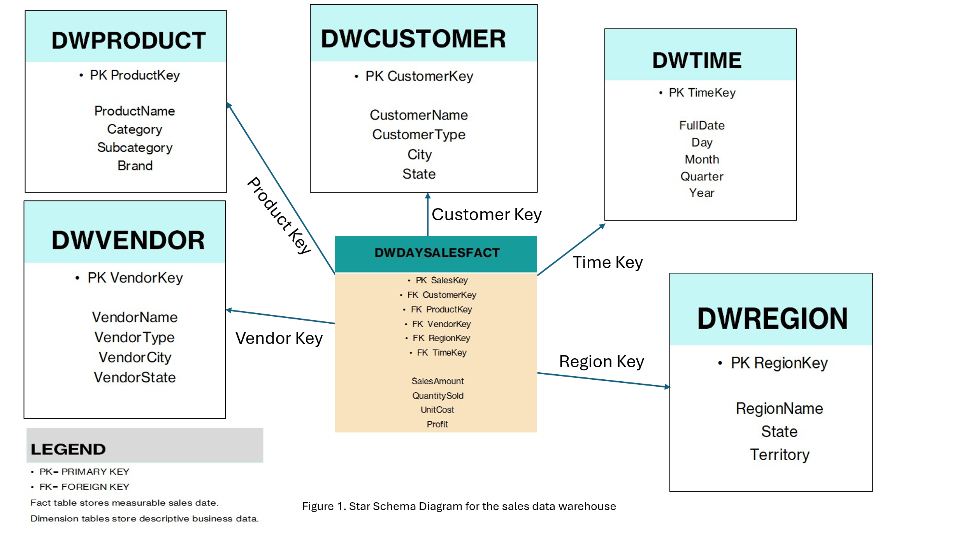

Testing Methods and Metrics

The way this project will focus on testing will be by taking data and validating the accuracy, consistency, and performance of the data warehouse system. Since the project is focused on a data warehouse rather than a web application, the testing process will verify that the data is extracted, transformed, loaded, and stored in the warehouse tables. Data validation will be tested by confirming that the data is accurate and consistent with the original source data. Query validation will be confirmed by checking that the query code returns the expected result for business questions. Such questions will pertain to the sales by the region, product performance, and time-based trends.

Delivery Plan
The project design document will include the overview, system architecture, functionality, database entity relationship model, scheduling, testing methods and metrics, delivery plan, and maintenance. The sections will come together to showcase how the data warehouse functions, is designed, and how it supports BI and decision-making.
The core functionality of the data warehouse will be designed in the initial version of the system. It will include source data integration, ETL processing, fact and dimension tables, and SQL queries for analysis. The initial version is designed to showcase the overall design and implantation of a sales data warehouse using a star schema structure. The major focus of the initial release will be analytical capabilities such as sales by region, product analysis, customer trends, and time-based reporting.

Other Documentation

File Structure
This project file structure will be organized to support the development, documentation, SQL implementation, and reporting functions of the data warehouse system. Since this is a data warehouse, this project will use folders that will reflect the different technical components of the warehouse environment.

Folder/File | Description
/data_sources/ | Raw source data files used for the project
/etl/ | Files related to extraction, transformation, and loading
/schema/ | Star schema design documents and database structure files
/sql/ | SQL scripts for table creation, inserts, and queries
/fact_tables/ | Documentation related to the fact table
/dimension_tables/ | Documentation related to dimension tables
/queries/ | Analytical SQL queries used for reporting
/reports/ | Generated reports and output summaries
/diagrams/ | System architecture, data flow, and schema diagrams
/appendices/ | Appendix materials such as screenshots and visuals
/docs/ | Project documentation and written sections
README.txt | General project overview and usage notes
References.docx | Reference list used in the design document
ProjectSchedule.xlsx | Timeline and project schedule
DesignDocument.docx | Main project design document

README Documentation
The readme file is used to provide the user with general information about he product they are using. For the project, the readme file will have a brief overview of the project and summarize the purpose of the project.

Maintenance
The maintenance of this project will focus on keeping the system accurate, efficient, and useful for reporting. It will include checking the ETL process to validate data quality, transformations, and ensuring data is loaded into the fact and dimension table correctly. If issues arise in the ETL process, it will negatively affect the reports accuracy and BI results.
In addition to checking the ETL process, another area of maintenance is query and schema optimization. As the volume of data starts to become larger, the query performance will need to be reviewed and checked for both speed and accuracy. The maintenance would involve things like updating the indexes, revising SQL queries, or adjusting the Schema design.

References
Bavdaž, M., Snijkers, G., Sakshaug, J. W., Brand, T., Haraldsen, G., Kurban, B., Saraiva, P., & Willimack, D. K. (2020). Business data collection methodology: Current state and future outlook. Statistical Journal of the IAOS, 36(3), 741–756. https://doi.org/10.3233/SJI-200623

Bechchi, M., Raschia, G., & Mouaddib, N. (2007). Merging distributed database summaries. In Proceedings of the 16th ACM Conference on Information and Knowledge Management (CIKM '07) (pp. 419–428). Association for Computing Machinery. https://doi.org/10.1145/1321440.1321500

Fahrner, C., & Vossen, G. (1995). A survey of database design transformations based on the Entity-Relationship model. Data & Knowledge Engineering, 15(3), 213–250. https://doi.org/10.1016/0169-023X(95)00006-E

Kimball, R., & Ross, M. (2013). The data warehouse toolkit: The definitive guide to dimensional modeling (3rd ed.). Wiley.

Mohammad Akel, I. R. (2025). The impact of organizational agility on business intelligence. Pakistan Journal of Life & Social Sciences, 23(1), 6588–6603. https://doi.org/10.57239/PJLSS-2025-23.1.00515

Necochea-Chamorro, J. I., & Larrea-Goycochea, L. (2023). Business intelligence applied in the corporate sector: A systematic review. TEM Journal, 12(4), 2225–2234. https://doi.org/10.18421/TEM124-33

Rabuzin, K., Cerjan, M., & Lovrenčić, A. (2025). Data warehouse design—Star schema synthesis algorithm. TEM Journal, 14(2), 1707–1714. https://doi.org/10.18421/TEM142-68

Reddy, S., et al. (2010). Data warehousing, data mining, OLAP and OLTP technologies are essential elements to support decision-making process in industries. https://www.researchgate.net/publication/50235148

Souibgui, M., Atigui, F., Zammali, S., Cherfi, S., & Ben Yahia, S. (2019). Data quality in ETL process: A preliminary study. Procedia Computer Science, 159, 676–687. https://doi.org/10.1016/j.procs.2019.09.223

Tarassenko, P. F., & Bukharova, M. S. (2001). System for database reports generating. In Proceedings of the 5th Korea-Russia International Symposium on Science and Technology (KORUS 2001) (Vol. 1, pp. 84–88). https://doi.org/10.1109/KORUS.2001.975063

Tryfona, N., Busborg, F., & Christiansen, J. G. B. (1999). StarER: A conceptual model for data warehouse design. In Proceedings of the 2nd ACM International Workshop on Data Warehousing and OLAP (DOLAP '99) (pp. 3–8). Association for Computing Machinery. https://doi.org/10.1145/319757.319776

APPENDIX A

System Architecture

Star Schema Diagram

Data Flow Diagram

APPENDIX B

B.1 Project Timeline

B.2 Sample SQL Scripts
CREATE TABLE DWDAYSALESFACT (
SalesKey INT PRIMARY KEY,
CustomerKey INT,
ProductKey INT,
VendorKey INT,
RegionKey INT,
TimeKey INT,
SalesAmount DECIMAL(10,2),
QuantitySold INT,
Profit DECIMAL(10,2)
);
CREATE TABLE DWCUSTOMER (
CustomerKey INT PRIMARY KEY,
CustomerName VARCHAR(100),
City VARCHAR(50),
State VARCHAR(50)
);

B.3 Sample Queries
-- Sales by Region
SELECT r.RegionName, SUM(f.SalesAmount) AS TotalSales
FROM DWDAYSALESFACT f
JOIN DWREGION r ON f.RegionKey = r.RegionKey
GROUP BY r.RegionName;
-- Top Products
SELECT p.ProductName, SUM(f.QuantitySold) AS TotalSold
FROM DWDAYSALESFACT f
JOIN DWPRODUCT p ON f.ProductKey = p.ProductKey
GROUP BY p.ProductName;

B.4 Query Results (Example)
Region Total Sales
East 150000
West 120000
Central 95000
Product Total Sold
Pump A 500
Valve B 320
Motor C 275

